Gabe Maturo

IS420

2/15/2021

Assignment 2

Task 1

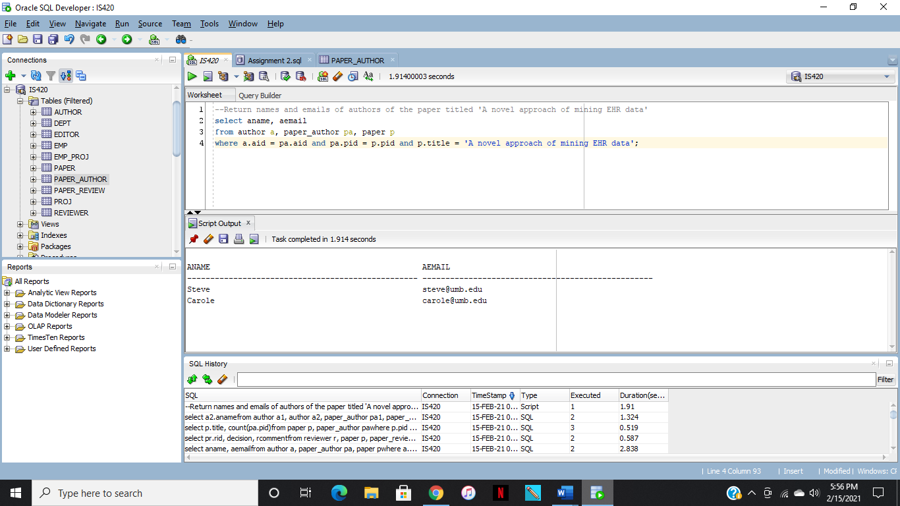

Task 2

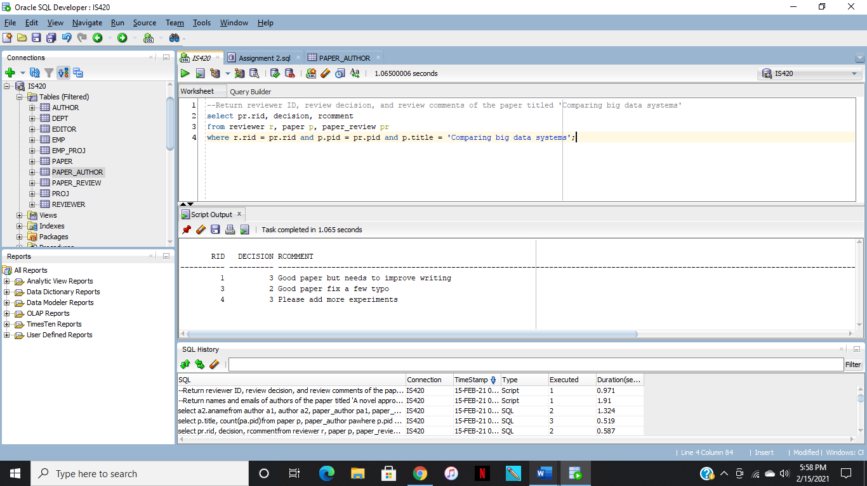

Task 3

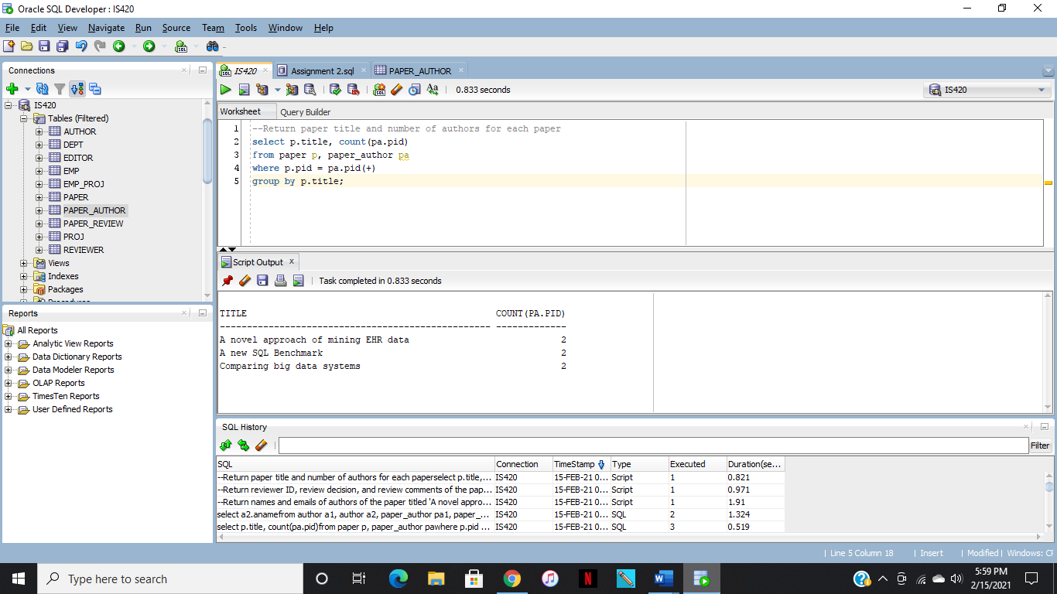

Task 4

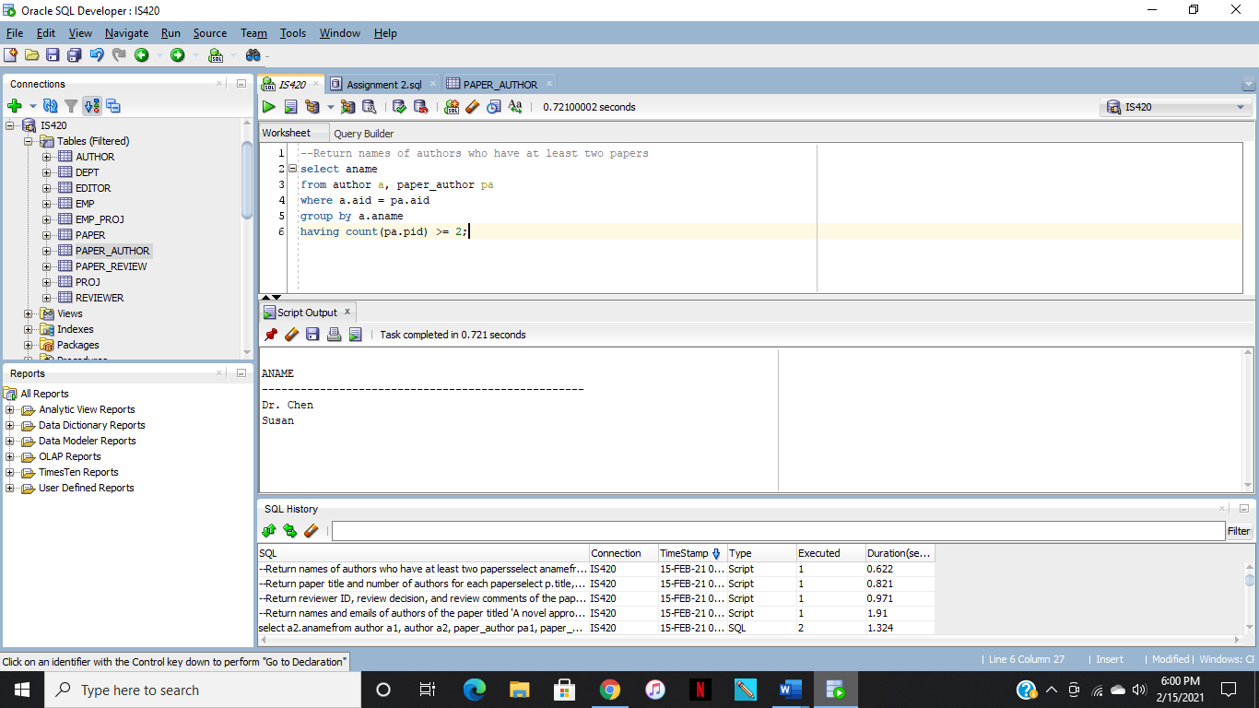

Task 5

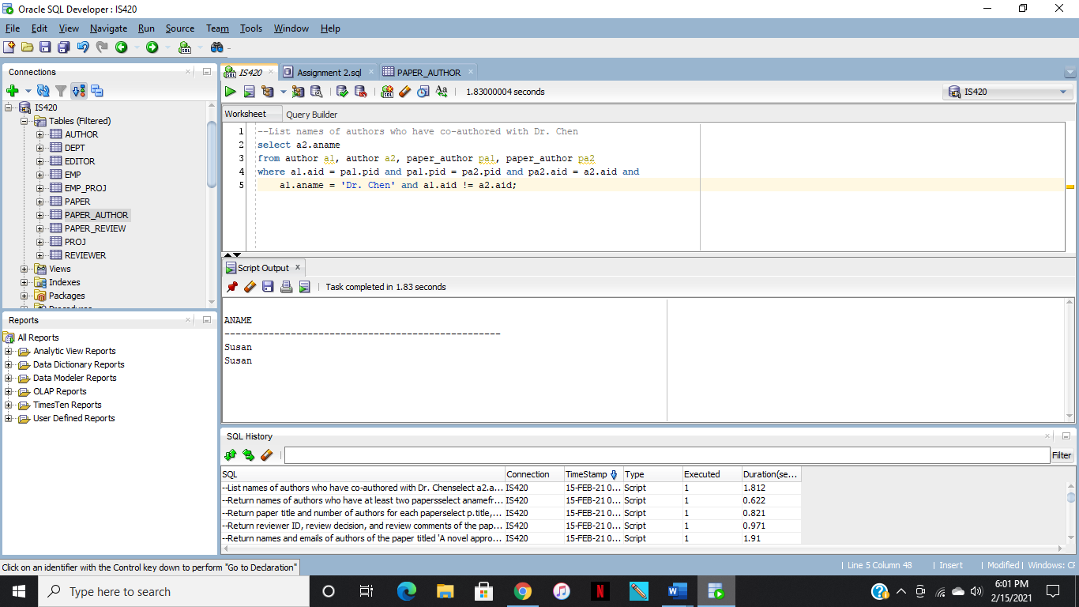

Code

Task 1

--Return names and emails of authors of the paper titled 'A novel approach of mining EHR data'

select aname, aemail

from author a, paper_author pa, paper p

where a.aid = pa.aid and pa.pid = p.pid and p.title = 'A novel approach of mining EHR data';

Task 2

--Return reviewer ID, review decision, and review comments of the paper titled 'Comparing big data systems'

select pr.rid, decision, rcomment

from reviewer r, paper p, paper_review pr

where r.rid = pr.rid and p.pid = pr.pid and p.title = 'Comparing big data systems';

Task 3

--Return paper title and number of authors for each paper

select p.title, count(pa.pid)

from paper p, paper_author pa

where p.pid = pa.pid(+)

group by p.title;

Task 4

--Return names of authors who have at least two papers

select aname

from author a, paper_author pa

where a.aid = pa.aid

group by a.aname

having count(pa.pid) >= 2;

Task 5

--List names of authors who have co-authored with Dr. Chen

select a2.aname

from author a1, author a2, paper_author pa1, paper_author pa2

where a1.aid = pa1.pid and pa1.pid = pa2.pid and pa2.aid = a2.aid and

a1.aname = 'Dr. Chen' and a1.aid != a2.aid;